Group Member Names: Allen George, Cristopher Falcon Ortiz, Abdalla Elattar

Course and Quarter: ENGR114 Fall 2018

Date: 12/9/2018

Revision Number: 1

**Stay Frosty Hardware Setup**

**Hardware Setup:**

**Bill of Materials:**

|  |  |  |  |  |
| --- | --- | --- | --- | --- |
| Part Name | Purpose | Item Name | URL | Price |
| Arduino Uno | Runs our program | Sparkfun Redboard | https://www.sparkfun.com/products/13975 | $19.95 |
| Breadboard | Building circuit | Breadboard - Self-Adhesive | https://www.sparkfun.com/products/12002 | $4.95 |
| Enclosure | Enclosure for Relay | Sparkfun Big Red Box | https://www.sparkfun.com/products/11366 | $8.95 |
| PIR Sensor | Input sensor for program | PIR (motion) sensor | https://www.adafruit.com/product/189 | $9.95 |
| Relay | Lets us power high voltage devices with low voltage Arduino | SparkFun Beefcake Relay Control Kit | https://www.sparkfun.com/products/13815 | $8.95 |
| Fan | Output of program | Received from Peter Kazarinoff | Received from Peter Kazarinoff | Received from Peter Kazarinoff |
| Jumper Cables | Connects components | Jumper Wires Standard 7" M/M - 30 AWG | https://www.sparkfun.com/products/11026 | $1.95 |
| Extension Cable | Connects to high voltage end of relay to plug into wall socket and fan | Received from PCC Maker Lab | Received from PCC Maker Lab | Received from PCC Maker Lab |
| Nylon Dome Strain Relief Connectors | Helps prevent component damage | Received from PCC Maker Lab | Received from PCC Maker Lab | Received from PCC Maker Lab |
| Mini-USB cable | Uploads program to Arduino | SparkFun USB Mini-B Cable - 6 Foot | https://www.sparkfun.com/products/11301 | $3.95 |
| Standoffs/Screws | Lifts relay off floor of enclosure | Received from PCC Maker Lab | Received from PCC Maker Lab | Received from PCC Maker Lab |
| Wire Nuts | Connects wires together and prevents them from contacting other elements/wires | Received from PCC Maker Lab | Received from PCC Maker Lab | Received from PCC Maker Lab |

Hardware Schematic:

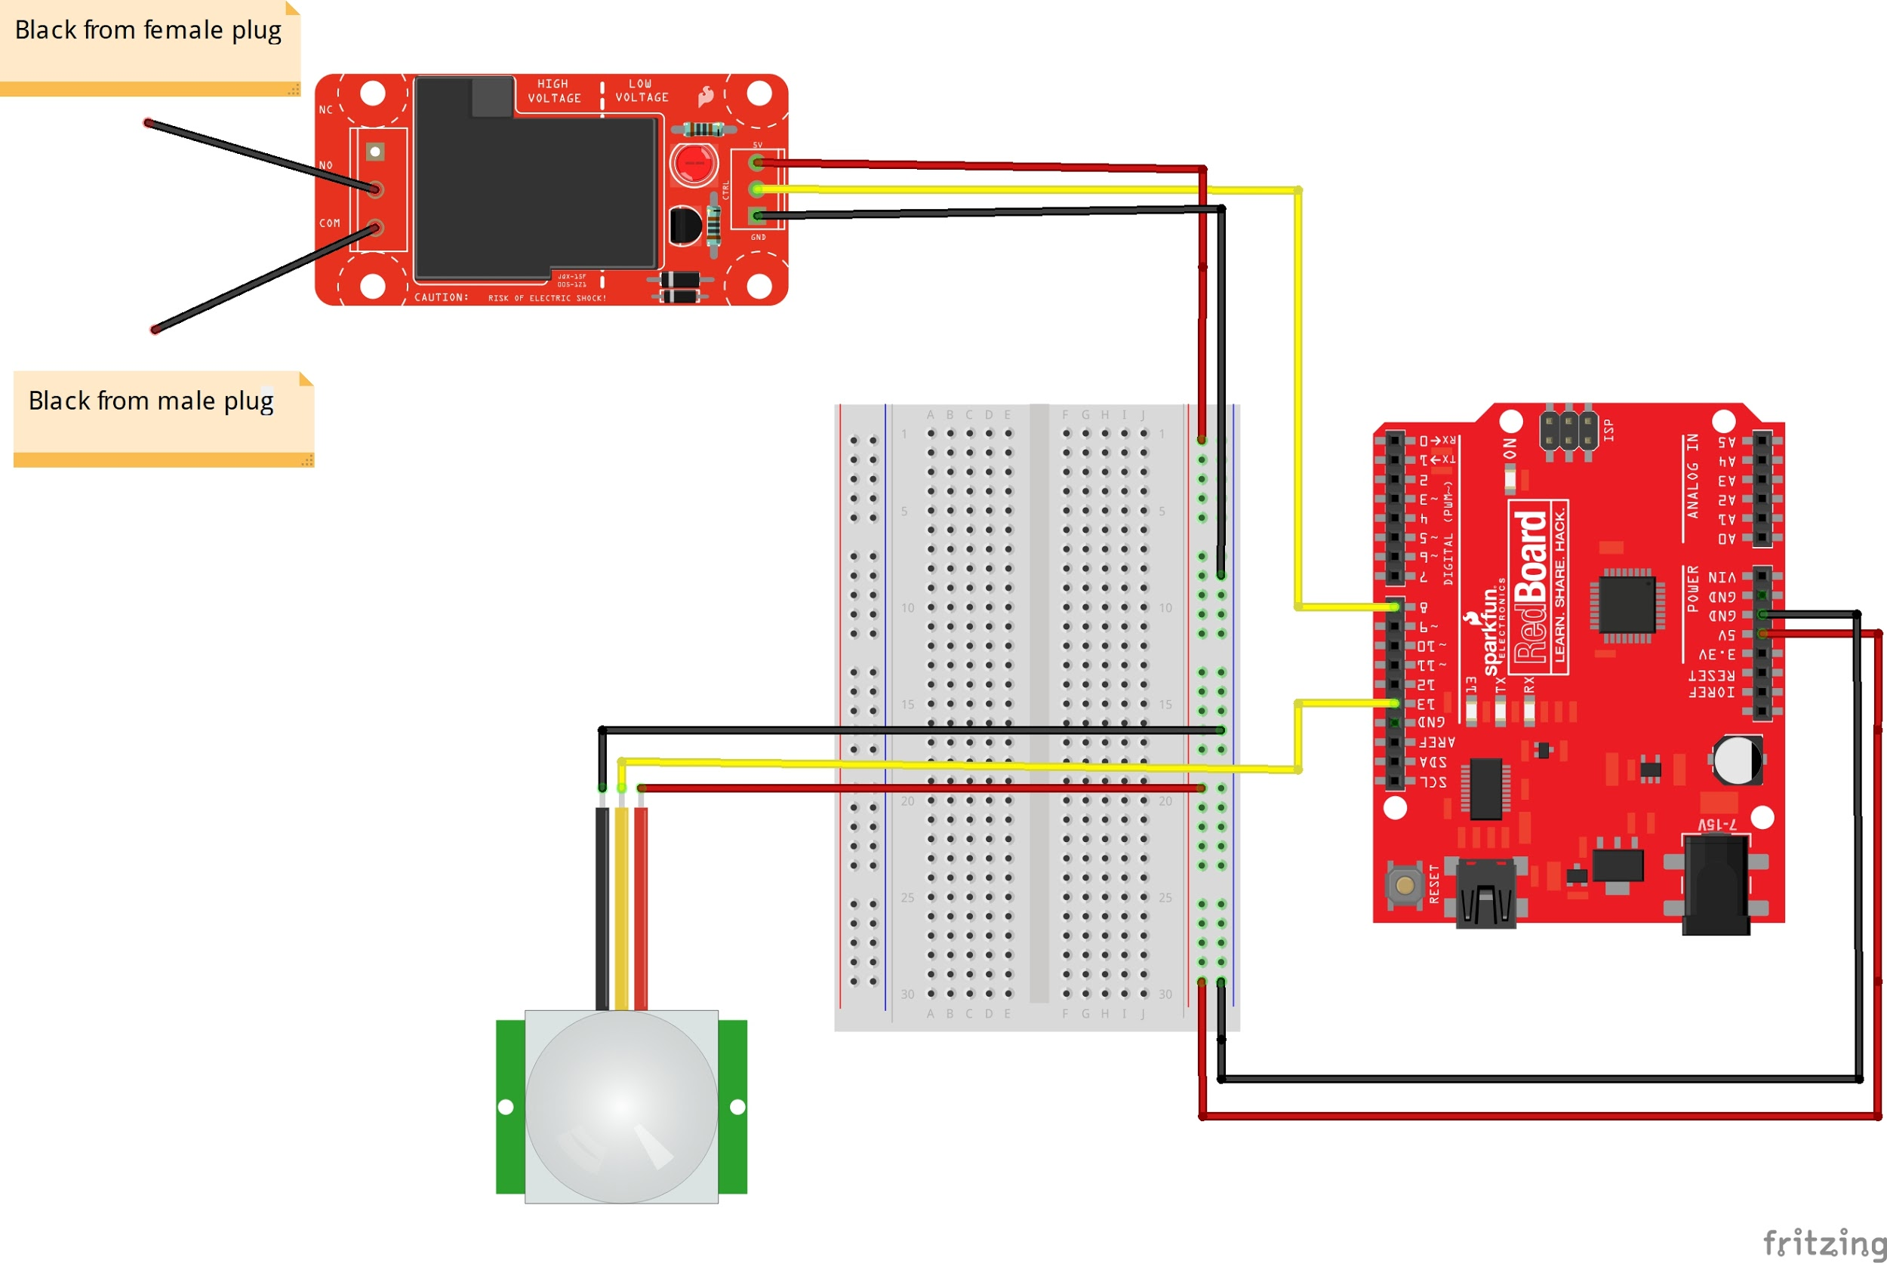

Hookup Guide:

|  |  |  |  |  |
| --- | --- | --- | --- | --- |
| Part | Pin | Connector | Pin | Part |
| PIR Sensor | 13 | Jumper Wire | 13 | Arduino Uno |
| Relay | 8 | Jumper Wire | 8 | Arduino Uno |

**Step 1:** Build the Beefcake relay. Follow instructions at https://learn.sparkfun.com/tutorials/beefcake-relay-control-hookup-guide?_ga=2.126438346.678827907.1495830299-657127905.1456517273

**Step 2:** Drill 3 holes into relay enclosure. 2 Large circular holes on each side to insert strain relief connectors, and 1 small hole so that the jumper cables have a point of exit.

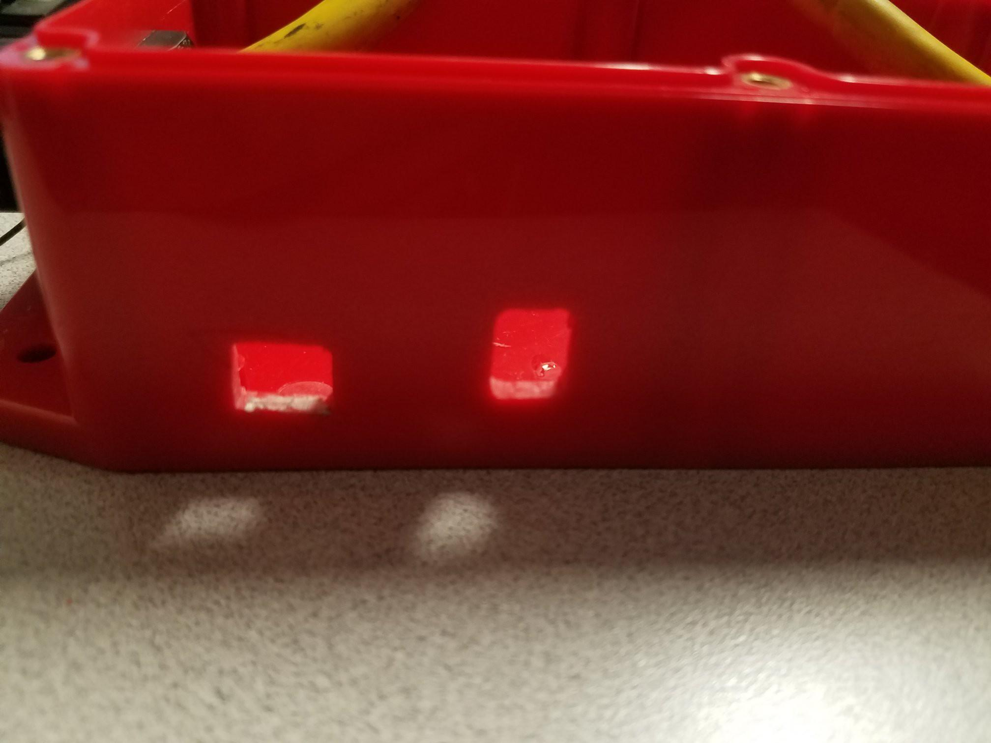

**Step 3**: Add standoffs onto the bottom of the enclosure, so that the relay will be raised off the ground. Simply add a dab of super glue to the bottom and place them where they need to be, so that the 4 standoffs line up with the 4 holes on the relay.

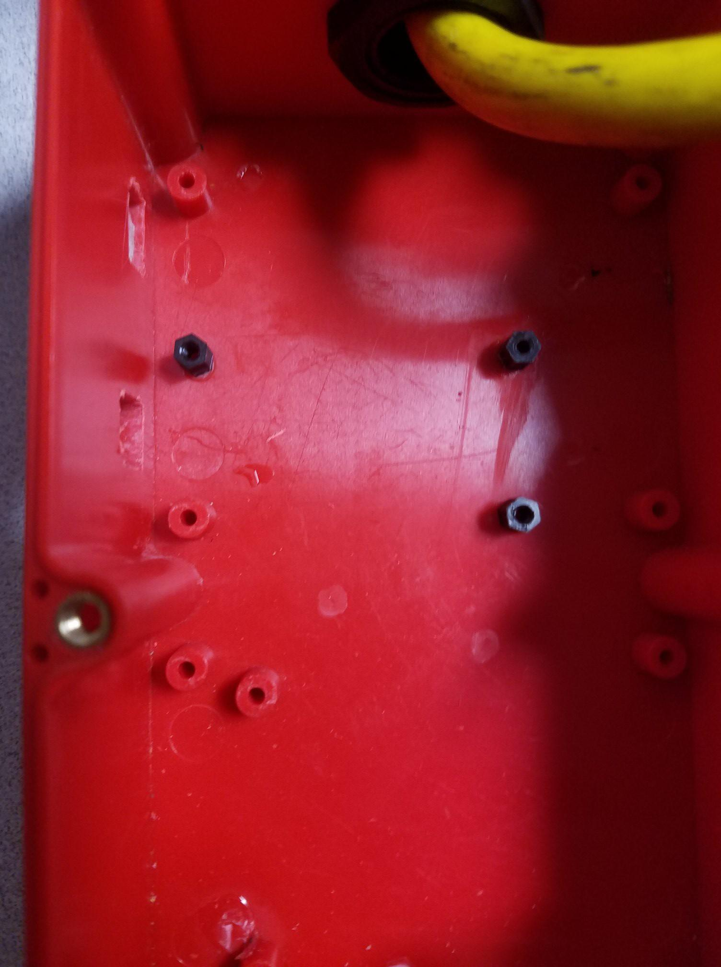

**Step 4:** Cut the extension cable so that the male end is much longer than the female end. The f emale end should be around a foot long and the male end should be the remaining amount. After that use a box cutter or another type of knife to remove about 4 inches of the rubber cover, exposing 3 wires on each end, black, white, and green. Finally, strip off about half an inch of the protective covering off each wire using wire strippers.

**Step 5:** Slip the strain relief connectors on each end of the extension cables, and connect them to the enclosure. Secure the strain relief connectors onto the enclosure. After that, using wire nuts, connect the white (neutral) wires together, and the green (ground) wires together.

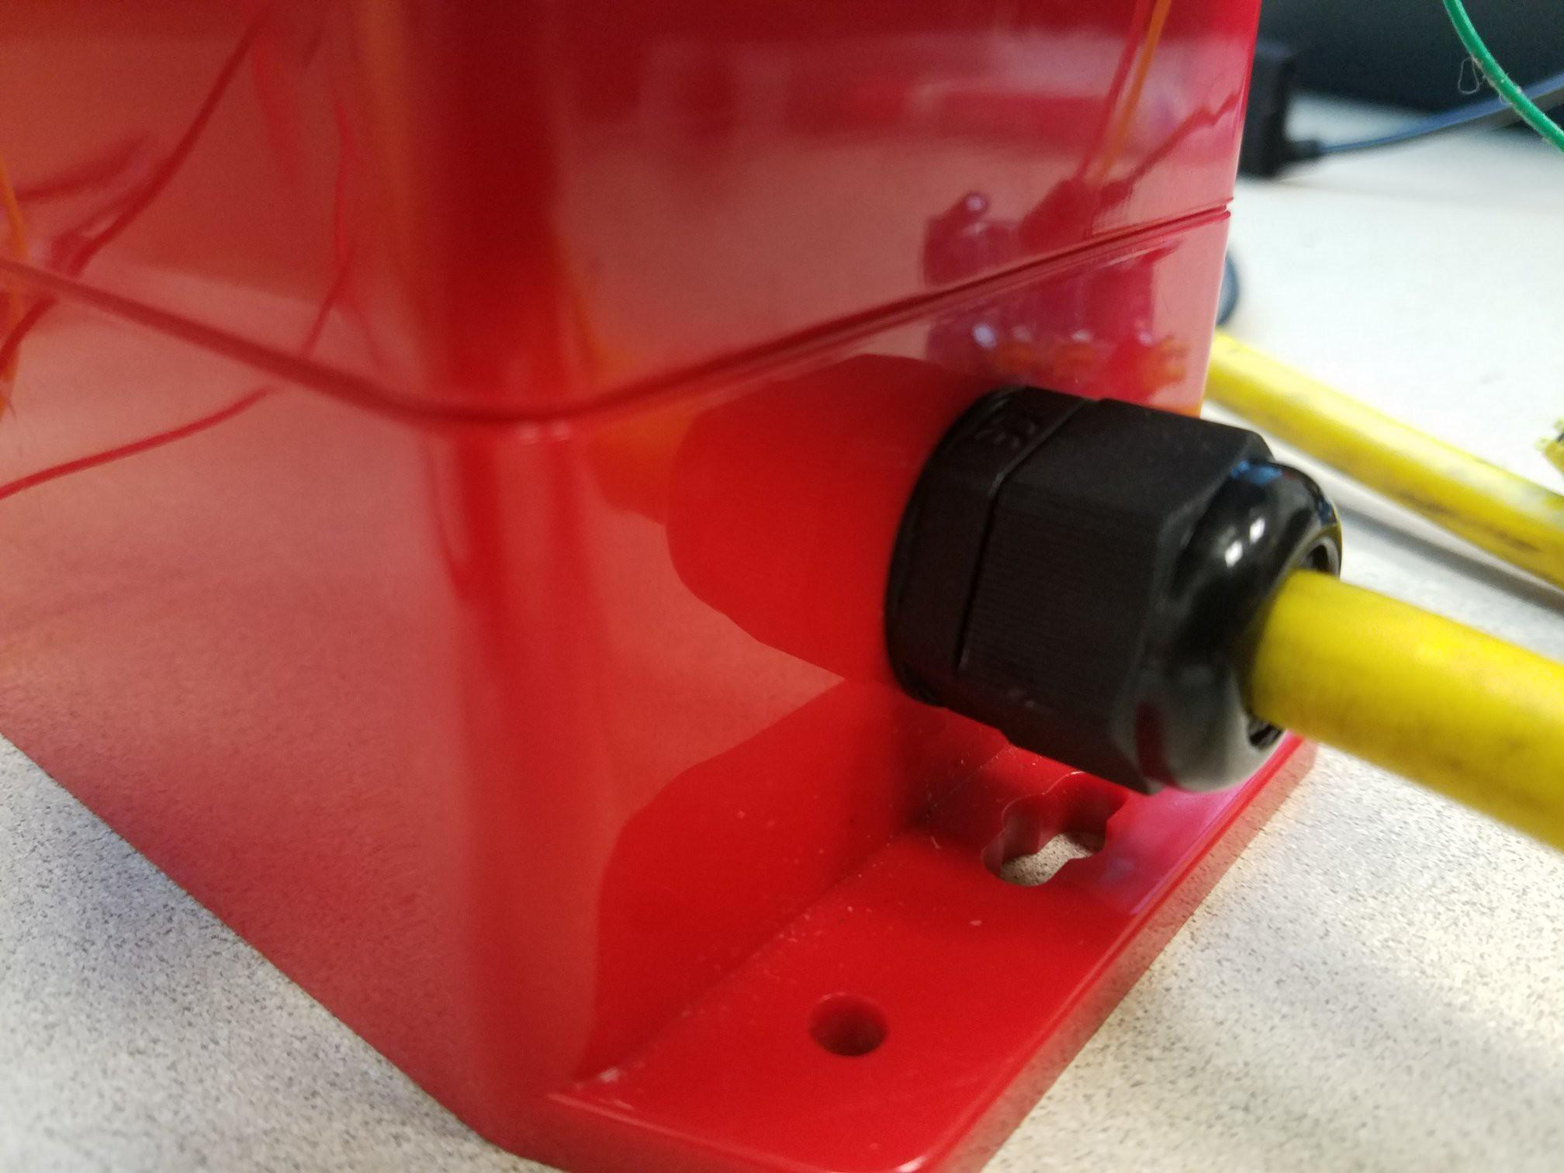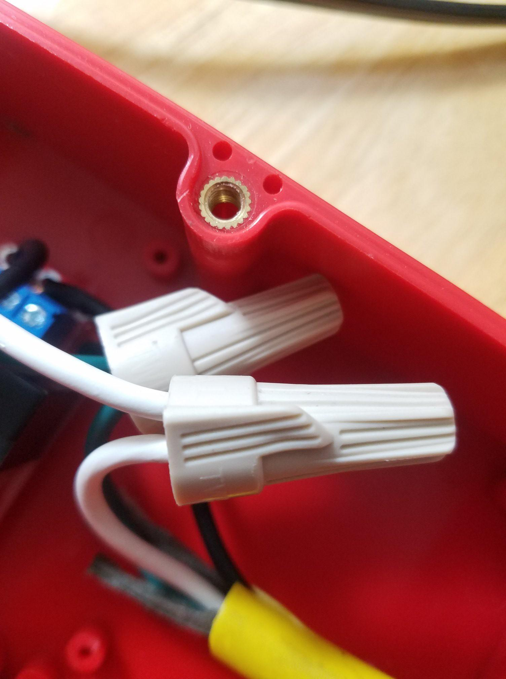

**Step 6:** Connect the black (hot) wires into the relay. The black from the male plug should go in the common (COM) terminal, and the black from the female plug should go in the normally open (NO) terminal. Once each wire is in, secure the connection by tightening the screws on the terminal. 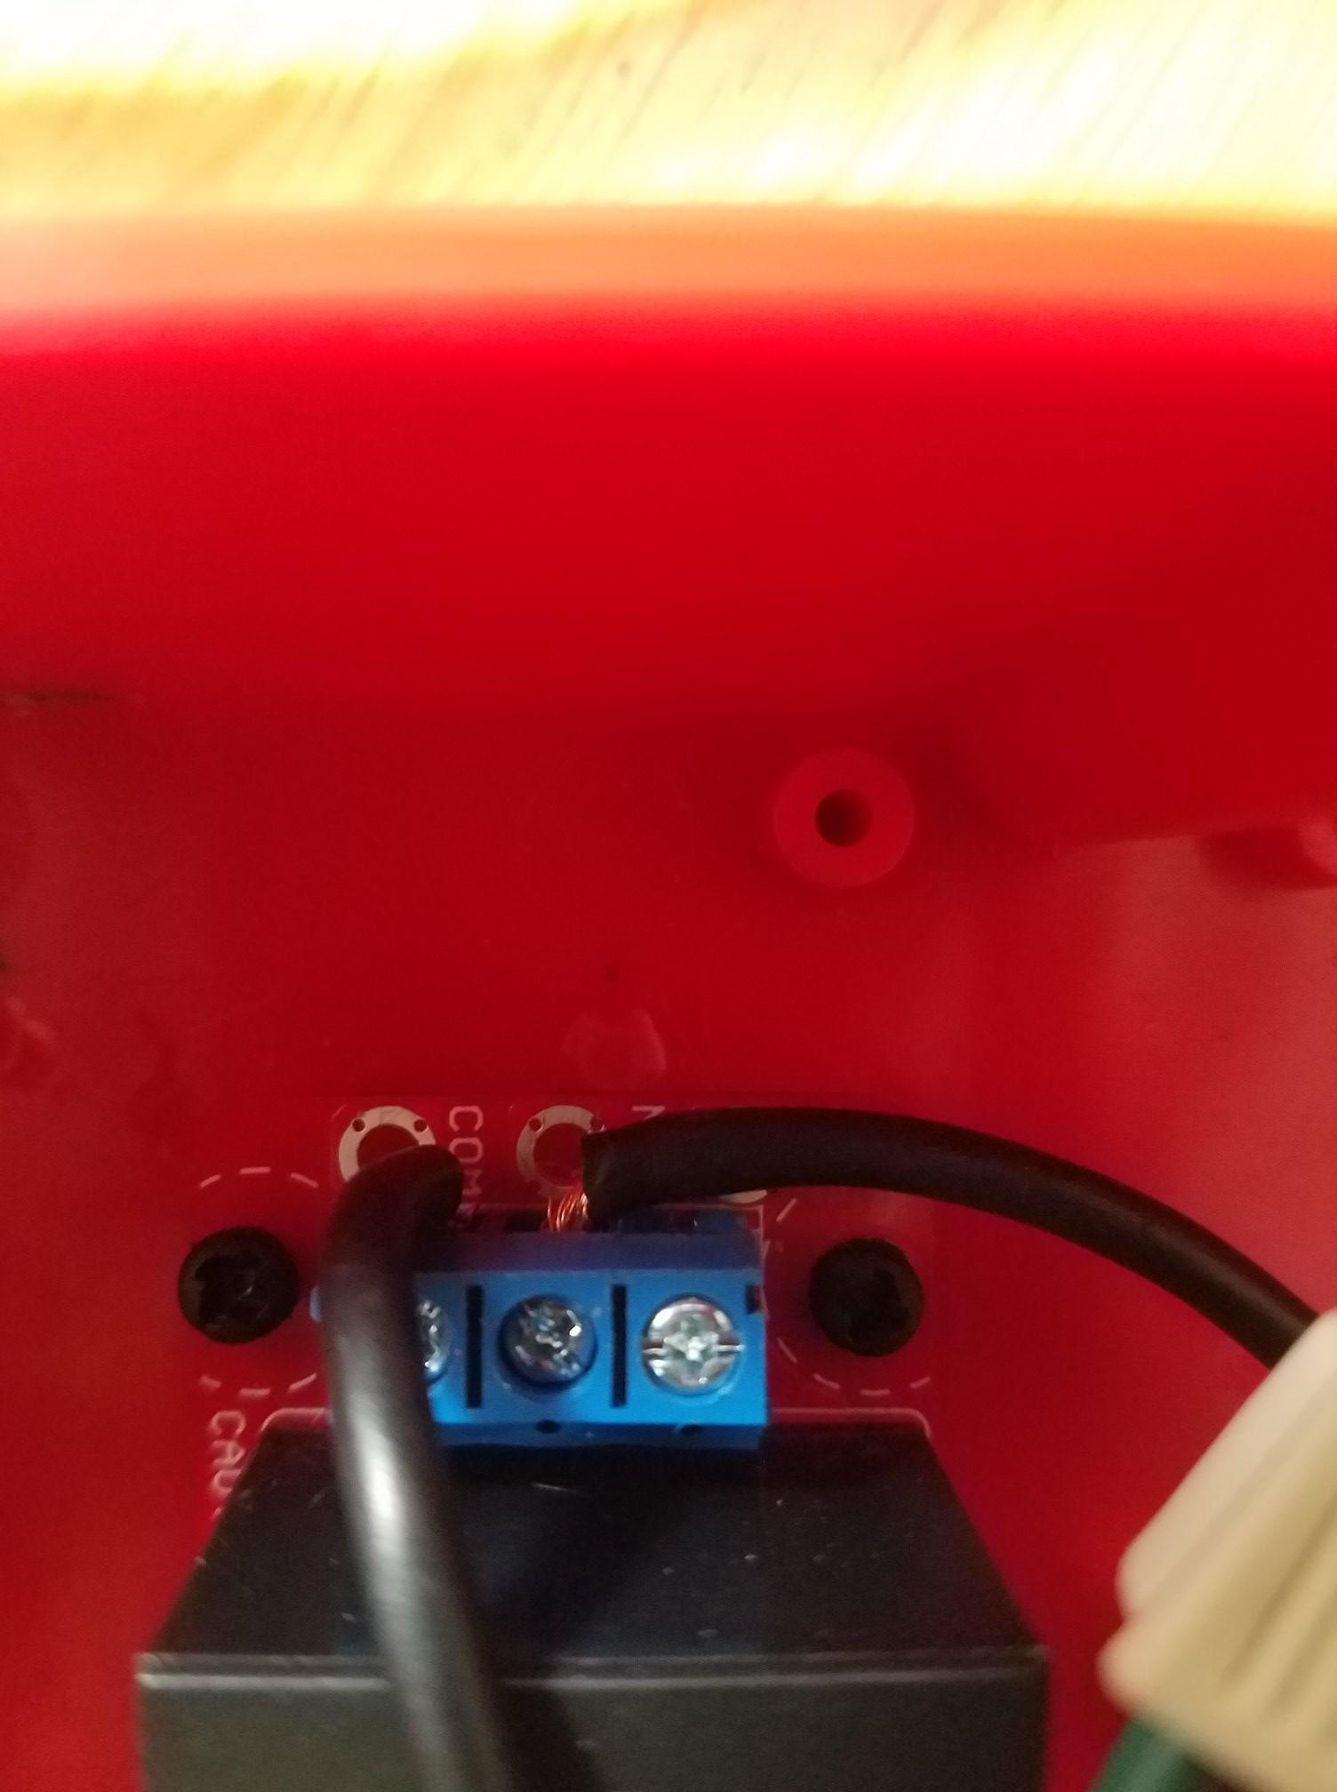

**Step 7:** Using the standoff screws, fasten the relay onto the enclosure into the standoffs we installed earlier. The low voltage end should be facing the hole that was drilled earlier, so that the terminals are fully accessible through the hole. Once all the wires are in and the relay is secured, tighten the strain relief connectors while allowing a little bit of slack.

**Step 8:** Connect jumper wires to the low voltage end. Black into ground (GND), yellow into control (CTRL), and red into power (5V). Secure the connections by tightening the screws. Now that the relay is complete, place the top of the enclosure back on and secure it with the screws it comes with.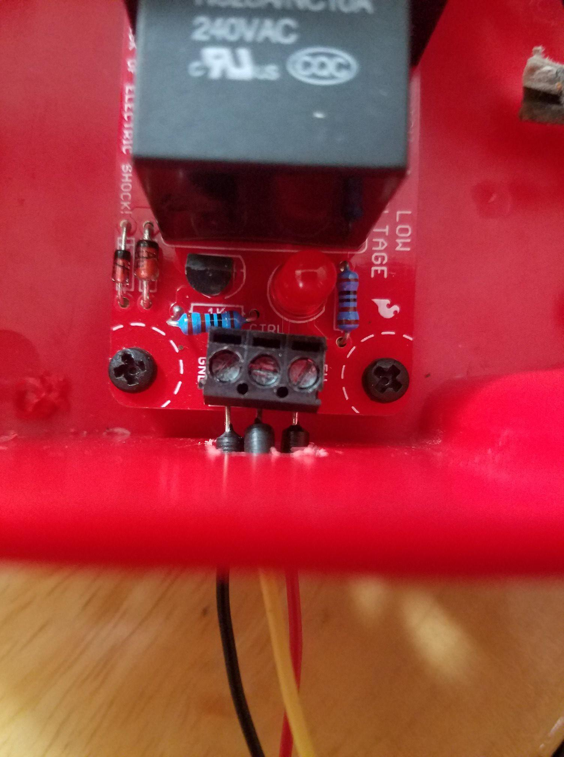

**Step 9:** Using a breadboard and the Arduino Uno, build the circuit specified by the Fritzing diagram, with the relay connected to digital pin 8 and the PIR sensor connected to digital pin 13.

**Step 10:** Plug fan into extension cable. After that, plug extension cable into a wall socket, and connect the mini-USB cable to your computer/laptop. The setup is now complete and you can now use the program.

**Final result:**

